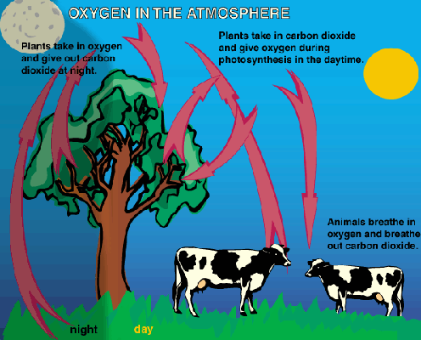
The Carbon Cycle
All living things are made of carbon.
Carbon is also a part of the ocean, air, and even rocks.
The Earth is a dynamic place, carbon does not stay still.
In the atmosphere, carbon is attached to some oxygen in a gas called carbon dioxide.
Plants use carbon dioxide and sunlight to make their own food and grow.
The carbon becomes part of the plant.
Plants that die and are buried may turn into fossil fuels made of carbon like coal and oil over millions of years.
When humans burn fossil fuels, most of the carbon quickly enters the atmosphere as carbon dioxide.
Carbon dioxide is a greenhouse gas and traps heat in the atmosphere.
Without it and other greenhouse gases, Earth would be a frozen world.
Humans have burned so much fuel that there is about 30% more carbon dioxide in the air today than there was about 150 years ago, and Earth is becoming a warmer place.
Ice cores show us that there is now more carbon dioxide in the atmosphere than there has been in the last 420,000 years.

